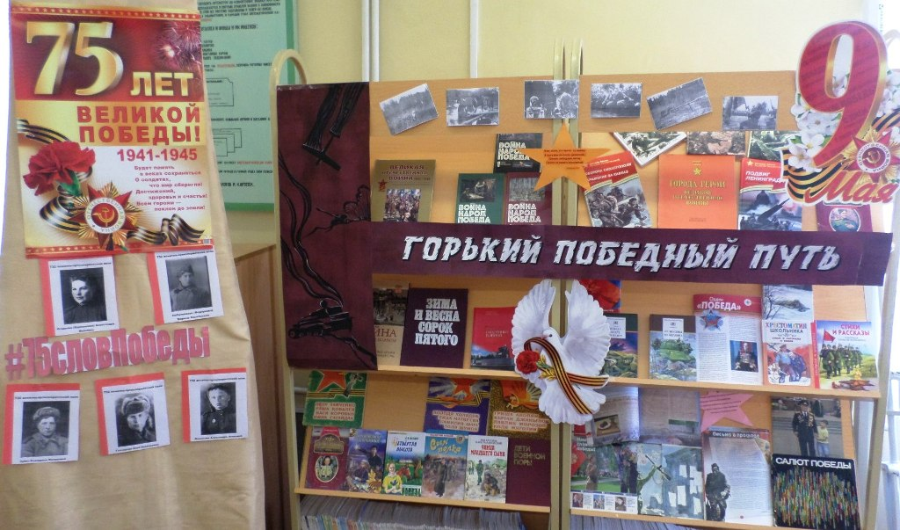

https://vk.com/public183520580
https://vk.com/public183520580?w=wall-183520580_83
https://vk.com/public183520580?w=wall-183520580_97
https://vk.com/public183520580?w=wall-183520580_98
https://vk.com/public183520580?w=wall-183520580_108

